**Николаев Денис 3ИП-1-22**

**Лабораторная работа 7**

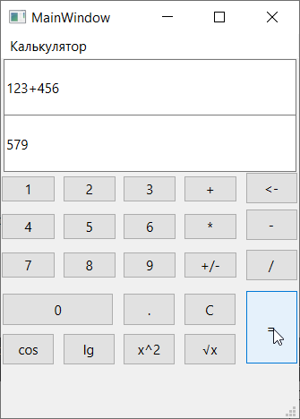

Рис. 1 Функция сложения

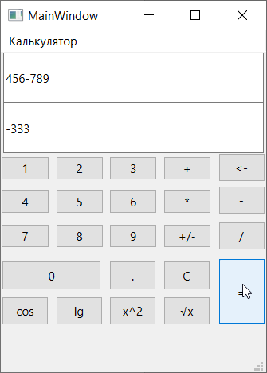

Рис. 2 Функция вычитания

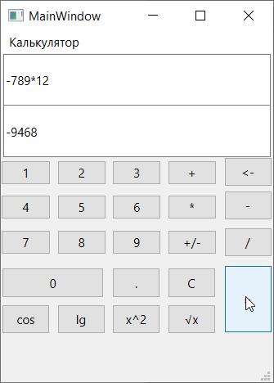

Рис. 3 Функция умножения с отрицательным числом

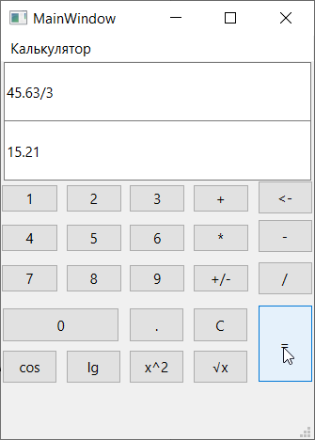

Рис. 4 Функция деления с вещественным числом

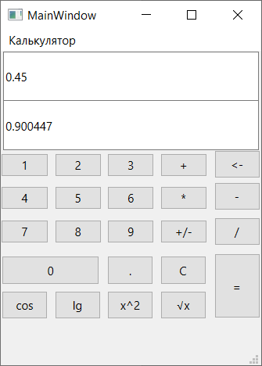

Рис. 5 Функция косинуса от числа

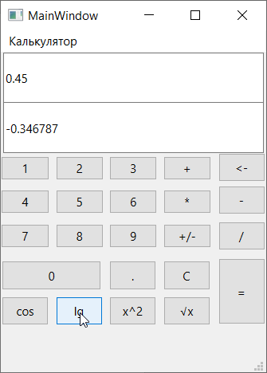

Рис. 6 Функция десятичного логарифма от числа

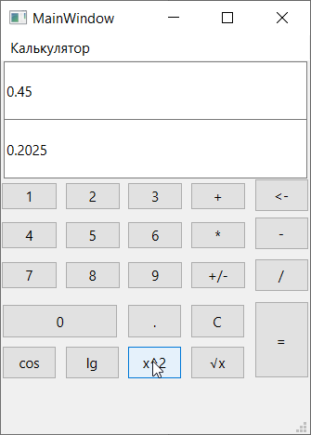

Рис. 7 Функция возведения числа в квадрат

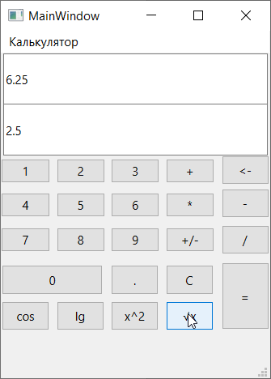

Рис. 8 Функция нахождения корня от числа

Код программы:

#include "mainwindow.h"

#include "ui_mainwindow.h"

MainWindow::MainWindow(QWidget *parent)

: QMainWindow(parent)

, ui(new Ui::MainWindow)

{

ui->setupUi(this);

}

MainWindow::~MainWindow()

{

delete ui;

}

QString num = "";

float num1 = 0;

float num2 = 0;

QString action = "none";

bool haveAction = false;

void MainWindow::on_One_clicked()

{

num += "1";

ui -> Nums -> setText(num);

}

void MainWindow::on_Two_clicked()

{

num += "2";

ui -> Nums -> setText(num);

}

void MainWindow::on_Three_clicked()

{

num += "3";

ui -> Nums -> setText(num);

}

void MainWindow::on_Four_clicked()

{

num += "4";

ui -> Nums -> setText(num);

}

void MainWindow::on_Five_clicked()

{

num += "5";

ui -> Nums -> setText(num);

}

void MainWindow::on_Six_clicked()

{

num += "6";

ui -> Nums -> setText(num);

}

void MainWindow::on_Seven_clicked()

{

num += "7";

ui -> Nums -> setText(num);

}

void MainWindow::on_Eight_clicked()

{

num += "8";

ui -> Nums -> setText(num);

}

void MainWindow::on_Nine_clicked()

{

num += "9";

ui -> Nums -> setText(num);

}

void MainWindow::on_Zero_clicked()

{

num += "0";

ui -> Nums -> setText(num);

}

void MainWindow::on_Point_clicked()

{

num += ".";

ui -> Nums -> setText(num);

}

void MainWindow::on_Plus_clicked()

{

if ((action != "+") && !haveAction)

{

if (action != "none")

{

num.chop(1);

}

action = "+";

haveAction = true;

num1 = (ui -> Nums -> text()).toFloat();

num += "+";

ui -> Nums -> setText(num);

}

}

void MainWindow::on_Times_clicked()

{

if ((action != "*") && !haveAction)

{

if (action != "none")

{

num.chop(1);

}

action = "*";

haveAction = true;

num1 = (ui -> Nums -> text()).toFloat();

num += "*";

ui -> Nums -> setText(num);

}

}

void MainWindow::on_Minus_clicked()

{

if ((action != "-") && !haveAction)

{

if (action != "none")

{

num.chop(1);

}

action = "-";

haveAction = true;

num1 = (ui -> Nums -> text()).toFloat();

num += "-";

ui -> Nums -> setText(num);

}

}

void MainWindow::on_Divide_clicked()

{

if ((action != "/") && !haveAction)

{

if (action != "none")

{

num.chop(1);

}

action = "/";

haveAction = true;

num1 = (ui -> Nums -> text()).toFloat();

num += "/";

ui -> Nums -> setText(num);

}

}

void MainWindow::on_Equals_clicked()

{

if (haveAction)

{

num2 = num.remove(0, (QString::number(num1).length()) + 1).toFloat();

if (action == "+")

{

ui -> Ans -> setText(QString::number(num1 + num2));

}

else if (action == "-")

{

ui -> Ans -> setText(QString::number(num1 - num2));

}

else if (action == "*")

{

ui -> Ans -> setText(QString::number(num1 * num2));

}

else

{

ui -> Ans -> setText(QString::number(num1 / num2));

}

num.clear();

action = "none";

haveAction = false;

}

}

void MainWindow::on_Clear_clicked()

{

num.clear();

action = "none";

haveAction = false;

ui -> Nums -> setText(num);

ui -> Ans -> setText("");

}

void MainWindow::on_Cos_clicked()

{

if (!haveAction)

{

num1 = (ui -> Nums -> text()).toFloat();

ui -> Ans -> setText(QString::number(cos(num1)));

}

}

void MainWindow::on_Lg_clicked()

{

if (!haveAction)

{

num1 = (ui -> Nums -> text()).toFloat();

ui -> Ans -> setText(QString::number(log10(num1)));

}

}

void MainWindow::on_Square_clicked()

{

if (!haveAction)

{

num1 = (ui -> Nums -> text()).toFloat();

ui -> Ans -> setText(QString::number(pow(num1, 2)));

}

}

void MainWindow::on_Root_clicked()

{

if (!haveAction)

{

num1 = (ui -> Nums -> text()).toFloat();

ui -> Ans -> setText(QString::number(sqrt(num1)));

}

}

void MainWindow::on_NegaPos_clicked()

{

if (!haveAction)

{

if (!num.startsWith("-"))

{

num = "-" + num;

ui -> Nums -> setText(num);

}

else

{

num.remove(0, 1);

ui -> Nums -> setText(num);

}

}

}

void MainWindow::on_Backspace_clicked()

{

if (num.endsWith("+") || num.endsWith("-") || num.endsWith("*") || num.endsWith("/"))

{

num.chop(1);

action = "none";

haveAction = false;

ui -> Nums -> setText(num);

}

else

{

num.chop(1);

}

ui -> Nums -> setText(num);

}